**ERD**

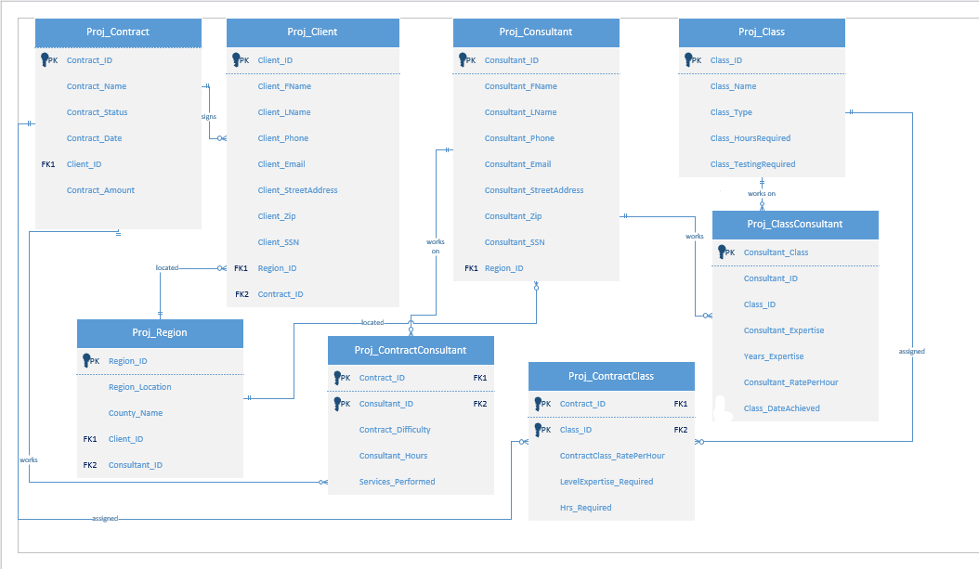

**Relational Diagram**

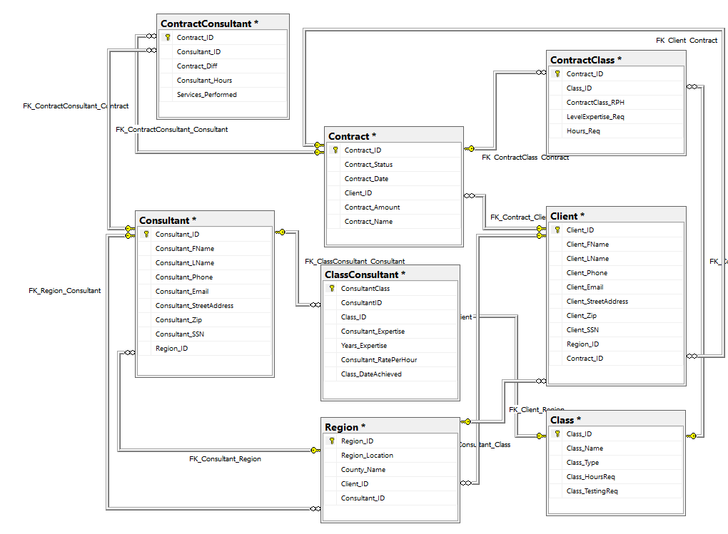

**3NF Relational Schema:**

**Region** (Region_ID, Region_Location, County_Name, *Client_ID*, *Consultant_ID*)

**Contract** (Contract_ID, Contract_Name, Contract_Status, Contract_Date, *Client_ID*, Contract_Amount)

**Client** (Client_ID, Client_FName, Client_LName, Client_Phone, Client_Email, Client_StreetAdress, Client_Zip, Client_SSN, *Region_ID*, *Contract_ID*)

**ContractConsultant** (*Contract_ID, Consultant_ID*, Contract_Difficulty, Consultant_Hours, Services_Performed)

**Consultant** (Consultant_ID, Consultant_FName, Consultant_LName, Consultant_Phone, Consultant_Email, Consultant_StreetAddress, Consultant_Zip, Consultant_SSN, *Region_ID*)

**ContractClass** (*Contract_ID, Class_ID,* ContractClass_RatePerHour, LevelExpertise_Required, Hrs_Required)

**Class** (Class_ID, Class_Name, Class_Type, Class_HoursRequired, Class_TestingRequired)

**ClassConsultant** (Consultant_Class, Consultant_ID, Class_ID, Years_Expertise, Consultant_Expertise, Consutlant_RatePerHours, Class_DateAchieved)

**Queries**

Query 1:

Description: Using these specific values from the Region, Client, and Consultant tables, we are identifying business relationships between the clients and consultants.

**SELECT Region_Location, County_Name, Client_FName, Client_LName, Consultant_FName, Consultant_LName**

**FROM Region, Client, Consultant**

**WHERE Region.Client_ID = Client.Client_ID**

**AND Region.Consultant_ID = Consultant.Consultant_ID**

**ORDER BY Region_Location;**

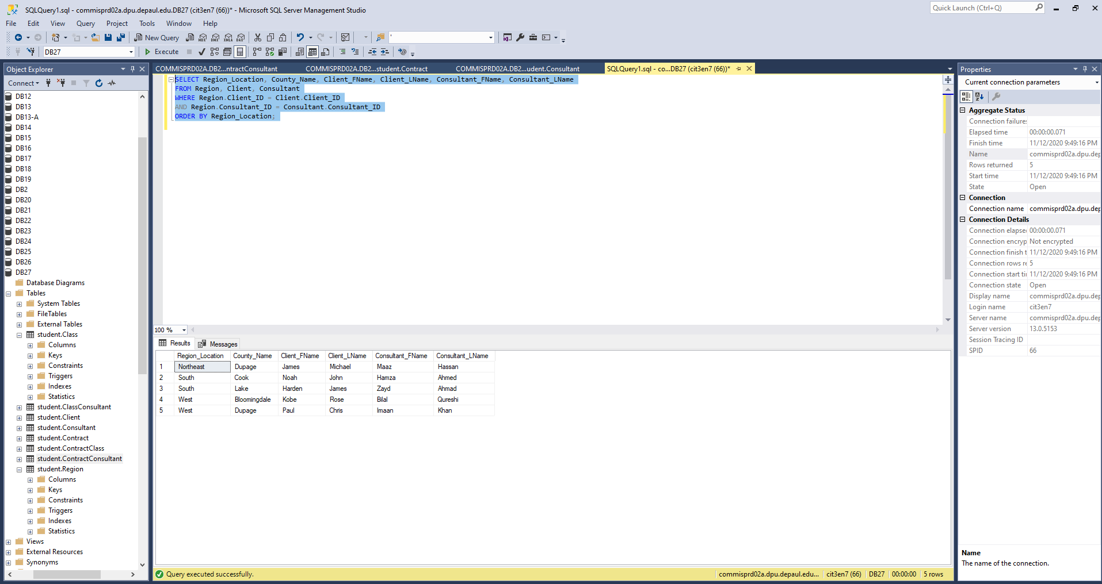

Query 2:

Description: Using values and relationships from the Contract, Consultant, and ContractConsultant tables, we find contracts that are still active.

**SELECT Contract_Status, Contract_Name, Consultant_FName, Consultant_LName**

**FROM Contract, Consultant, ContractConsultant**

**WHERE Consultant.Consultant_ID=ContractConsultant.Consultant_ID**

**AND ContractConsultant.Contract_ID=Contract.Contract_ID**

**AND Contract_Status != 'Complete'**

**ORDER BY Contract_Status;**

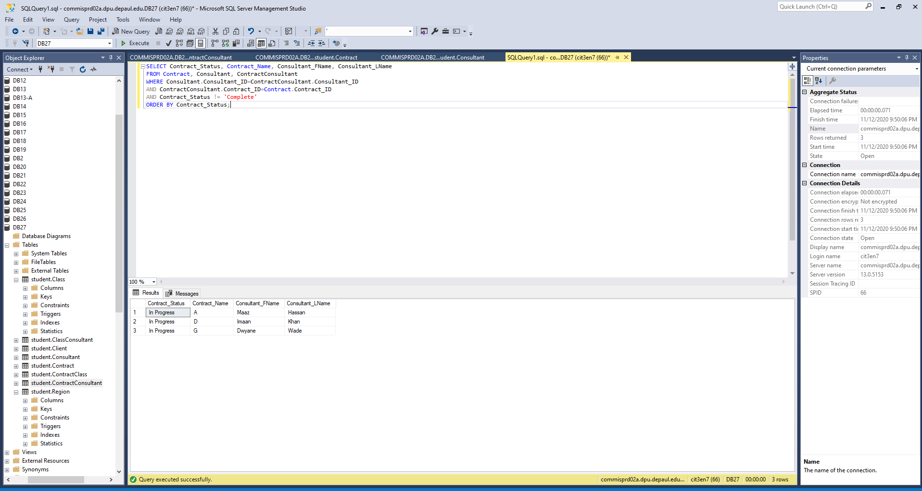

Query 3:

Description: This will identify which clients and consultants are located in the same geographic region.

**SELECT Region_Location, County_Name, Client_FName, Client_LName, Consultant_FName, Consultant_LName**

**FROM Region, Client, Consultant**

**WHERE Consultant.Consultant_ID=Region.Consultant_ID**

**AND Client.Client_ID=Region.Client_ID**

**GROUP BY Client_FName, Client_LName, Consultant_FName, Consultant_LName, Region_Location, County_Name**

**ORDER BY Region_Location, County_Name;**

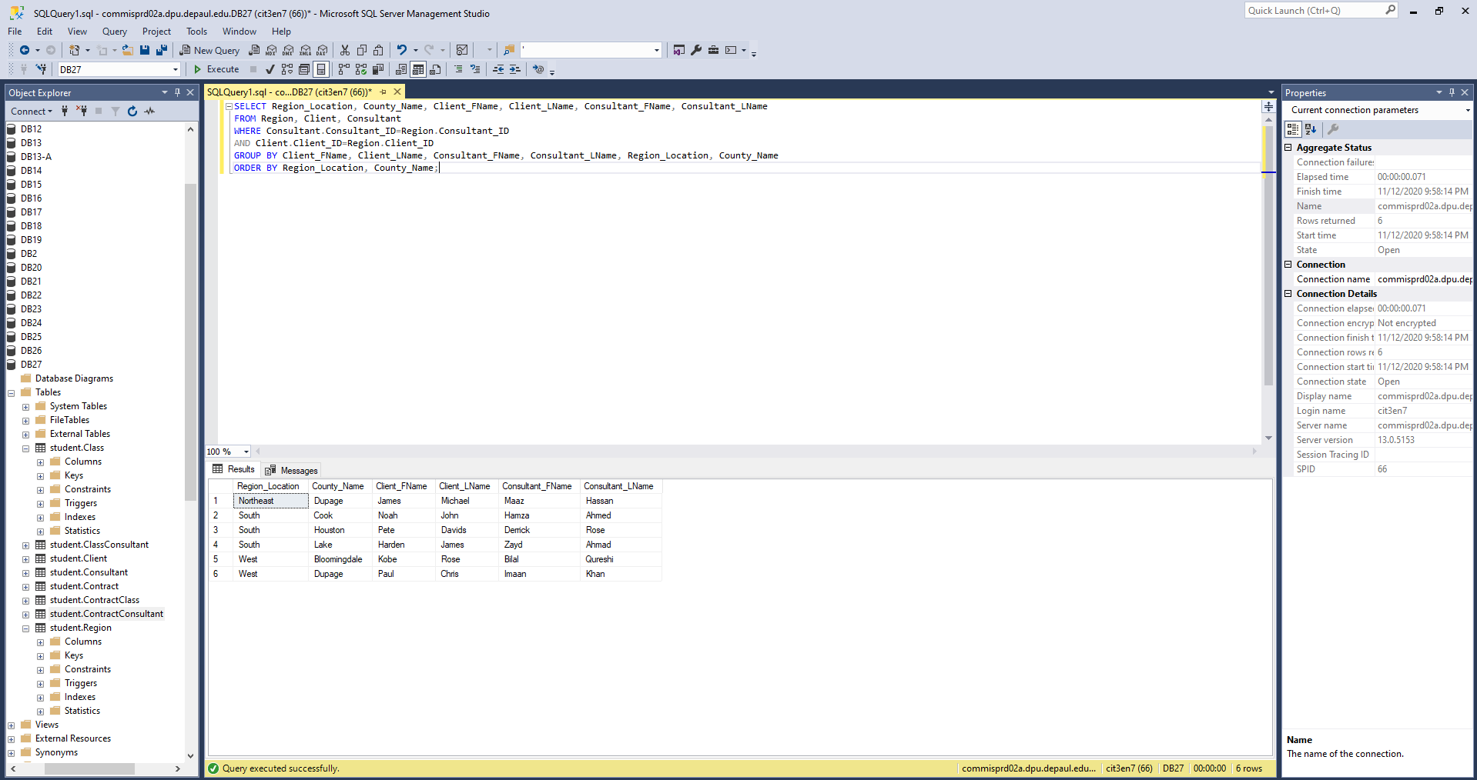

Query 4:

Description: This will filter out data from the Region table to identify consultants by region.

**SELECT Region_Location, COUNT(Region.Region_Location) AS Number_Of_Consultants**

**FROM Region**

**GROUP BY Region_Location;**

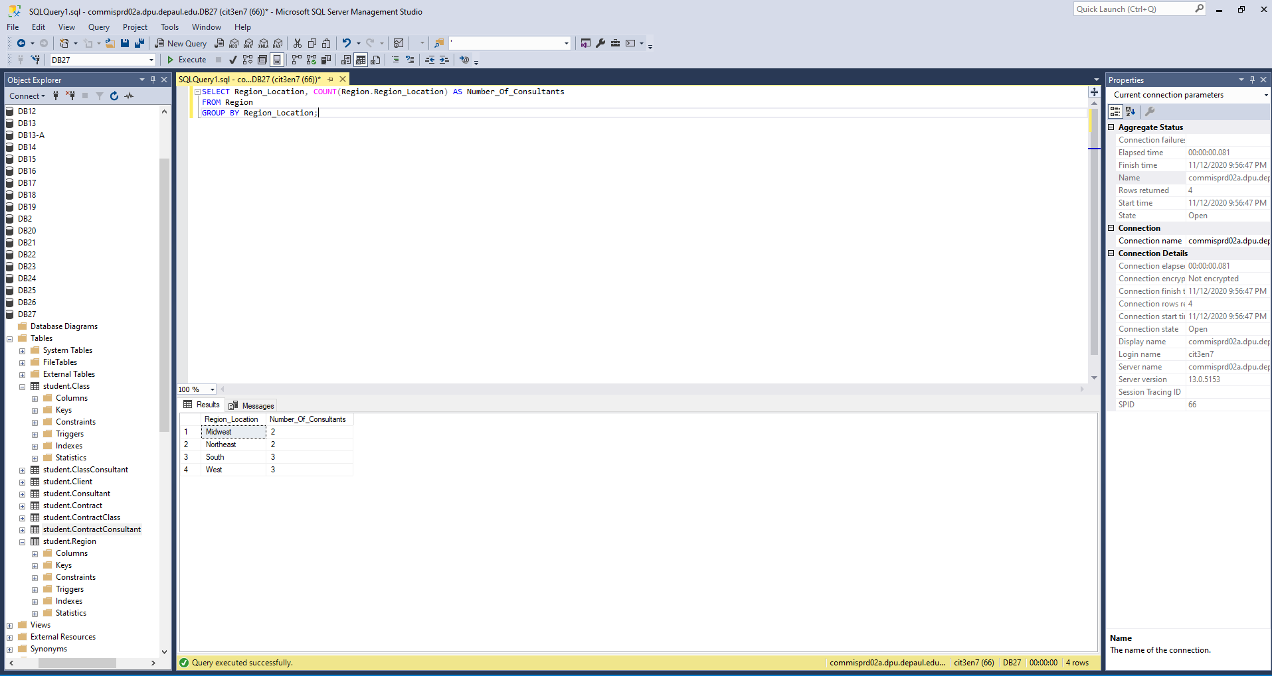

Query 5:

Description: This will identify all the relevant information of each consultant.

**SELECT Consultant.Consultant_ID, Consultant_FName, Consultant_LName, Consultant_Phone, Consultant_StreetAddress, Consultant_Zip, Consultant_Email,**

**Region_Location, Consultant_Expertise, Years_Expertise, Consultant_RatePerHour, Contract_ID**

**FROM Consultant, Region, ContractConsultant, ClassConsultant**

**WHERE Region.Consultant_ID=Consultant.Consultant_ID**

**AND ClassConsultant.ConsultantID=Consultant.Consultant_ID**

**AND ContractConsultant.Consultant_ID=Consultant.Consultant_ID**

**ORDER BY Consultant_ID;**

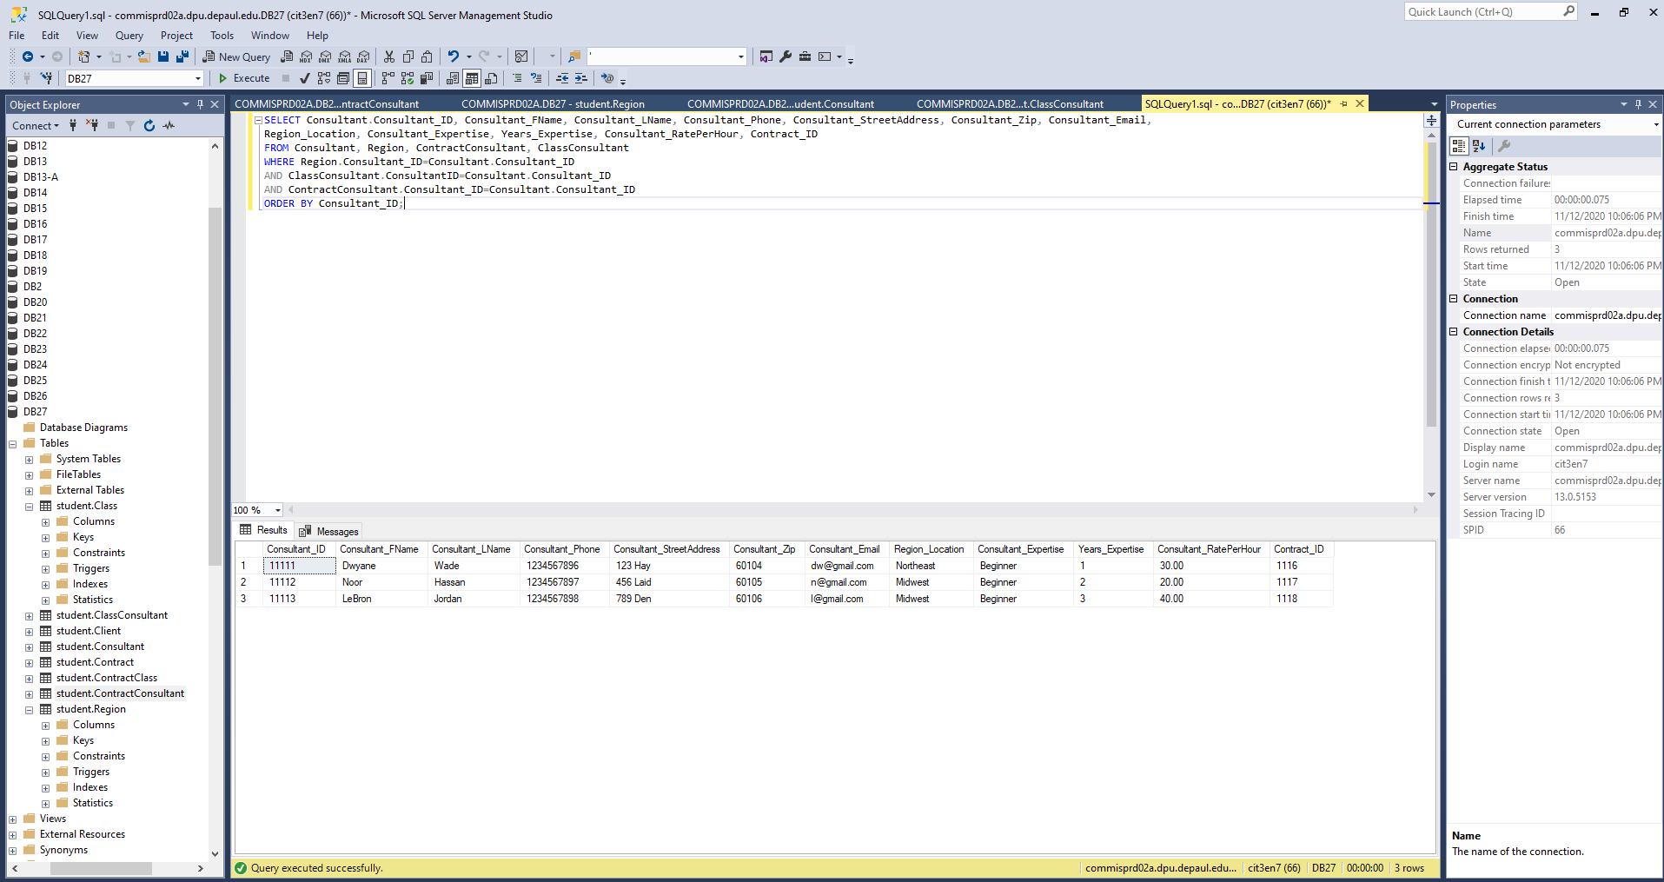

Query 6:

Description: This query displays all contracts that are currently in progress. This could help someone take out all complete contracts and only see those that are in progress.

**SELECT Contract_Name, Contract_Status, Contract_Diff**

**FROM Contract, ContractConsultant**

**WHERE Contract.Contract_ID = ContractConsultant.Contract_ID and Contract_Status='In Progress';**

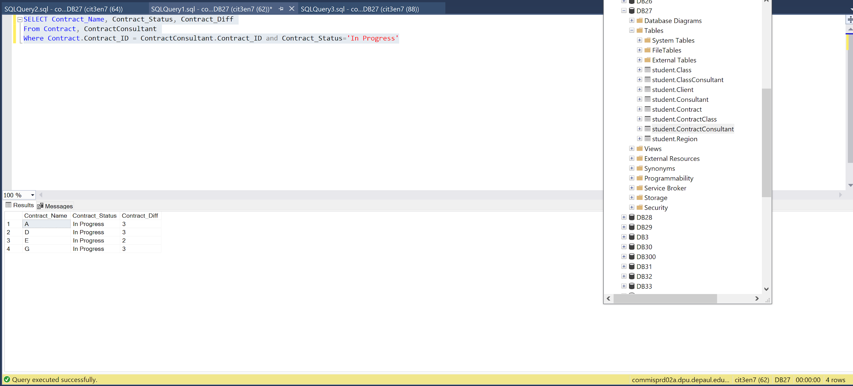

Query 7:

Description: This query displays contracts that are not complete and have a difficulty level of 3. This could be useful in seeing active contracts that are the most difficult.

**SELECT Contract_Name, Contract_Status, Contract_Diff**

**FROM Contract, ContractConsultant**

**WHERE Contract.Contract_ID = ContractConsultant.Contract_ID**

**AND Contract_Diff='3'**

**AND Contract_Status !='Complete';**

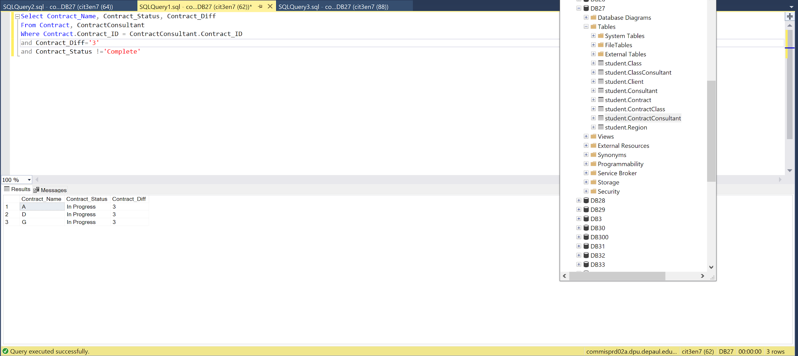

Query 8:

Description: This query shows contracts that are not complete and have a difficulty of 2. This is useful for finding past contracts that are of moderate difficulty.

**SELECT Contract_Name, Contract_Status, Contract_Diff**

**FROM Contract, ContractConsultant**

**WHERE Contract.Contract_ID = ContractConsultant.Contract_ID**

**AND Contract_Diff='2'**

**AND Contract_Status!='Complete';**

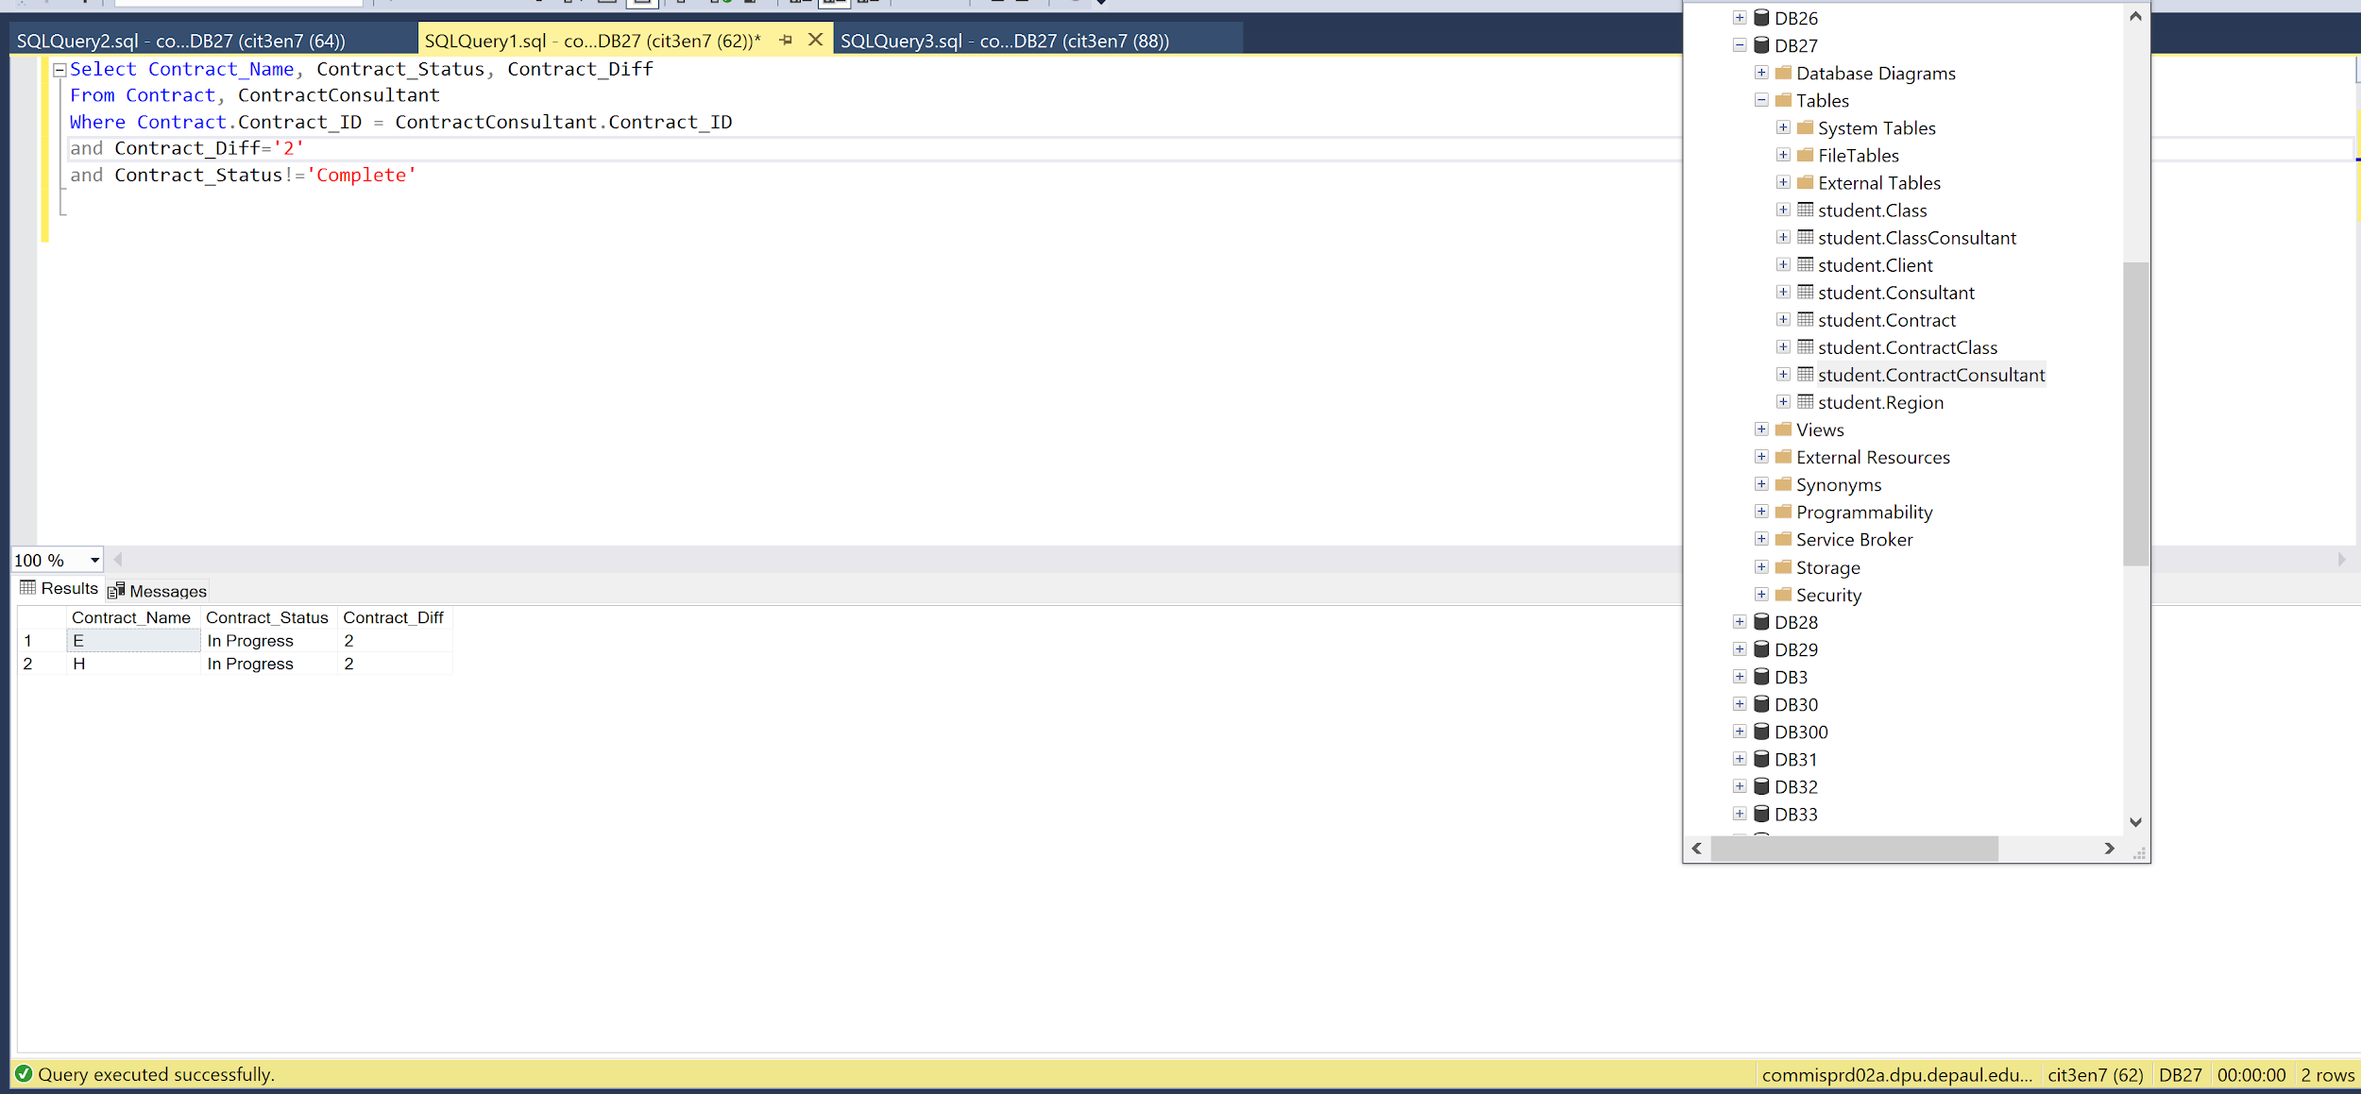

Query 9:

Description: This query shows contract information that includes the contract name, the status, the date, and the client's name and ID. This could be helpful when searching for the status of contracts and which clients they are for, as well as the contract date.

**SELECT Contract.Contract_ID, Contract_Name, Contract_Status, Contract_Date,Client_FName, Client_LName, Client.Client_ID**

**FROM Contract, Client**

**WHERE Contract.Client_ID=Client.Client_ID**

**ORDER BY Contract_ID;**

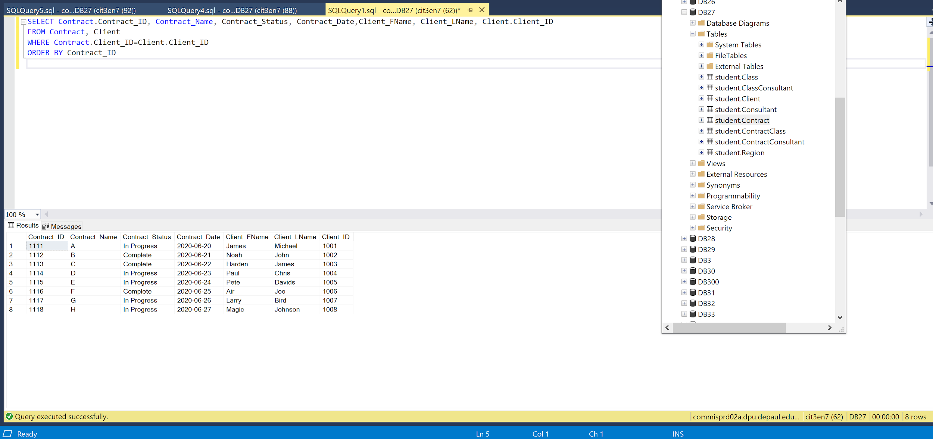

Query 10:

Description: This query displays client Information including the Client’s ID, Name, Phone, Address, and Region Location. This could be helpful for a business trying to search for a specific clients email address and phone number.

**SELECT Client.Client_ID, Client_FName, Client_LName, Client_Phone, Client_StreetAddress, Client_Zip, Client_Email, Region_Location**

**From Client, Region**

**WHERE Region.Region_ID=Client.Region_ID**

**ORDER BY Client_ID;**

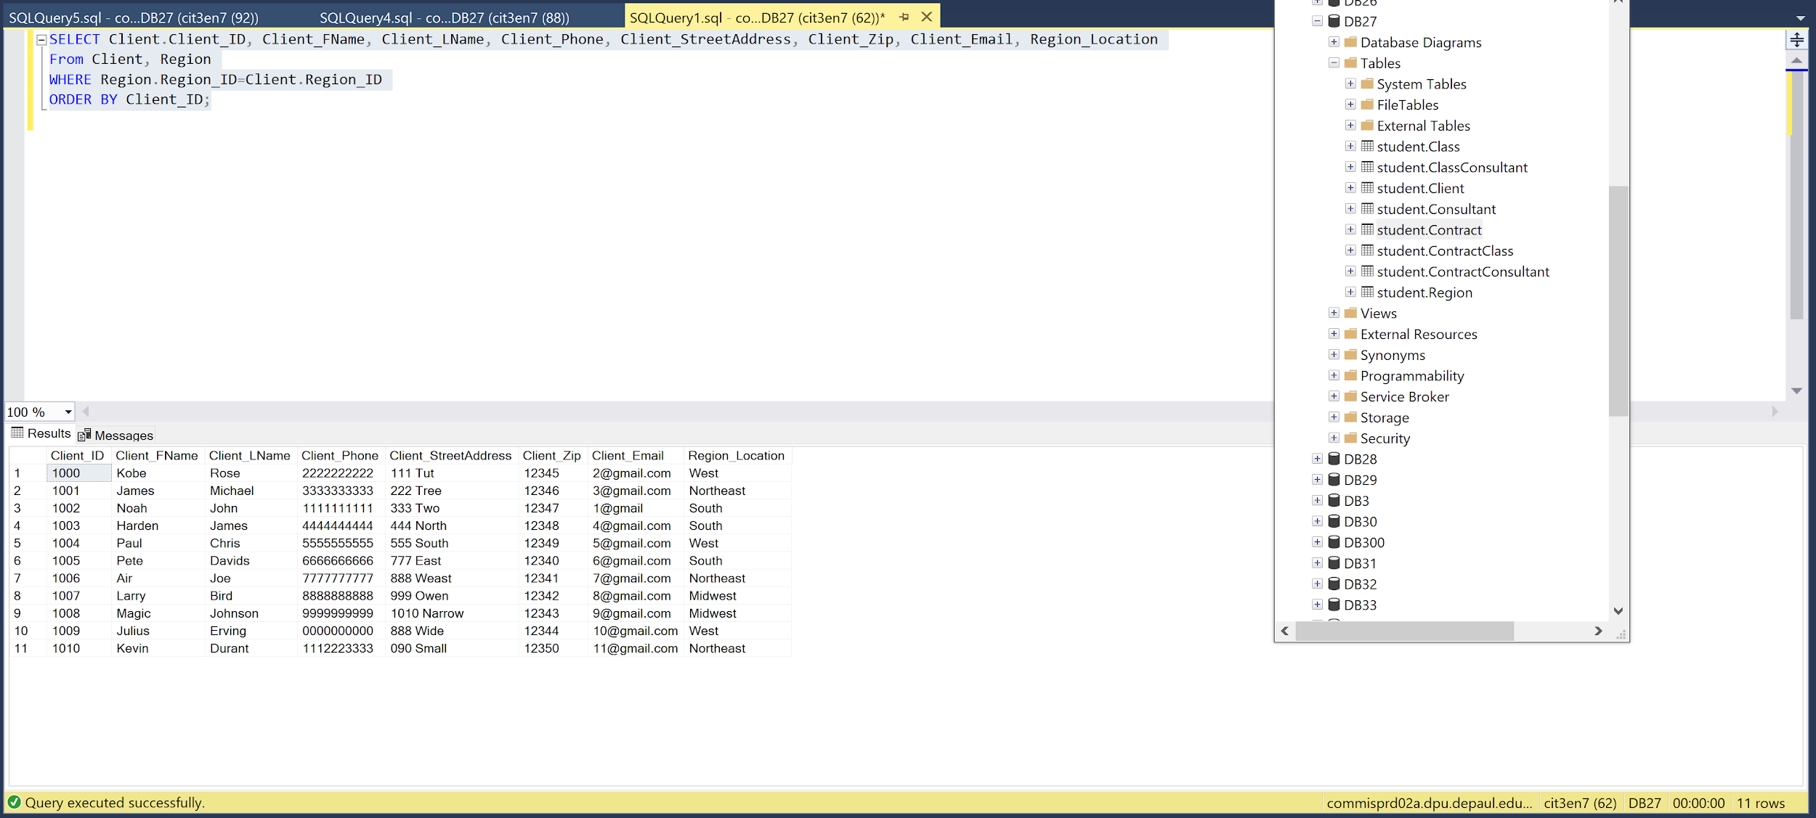

**TABLES**

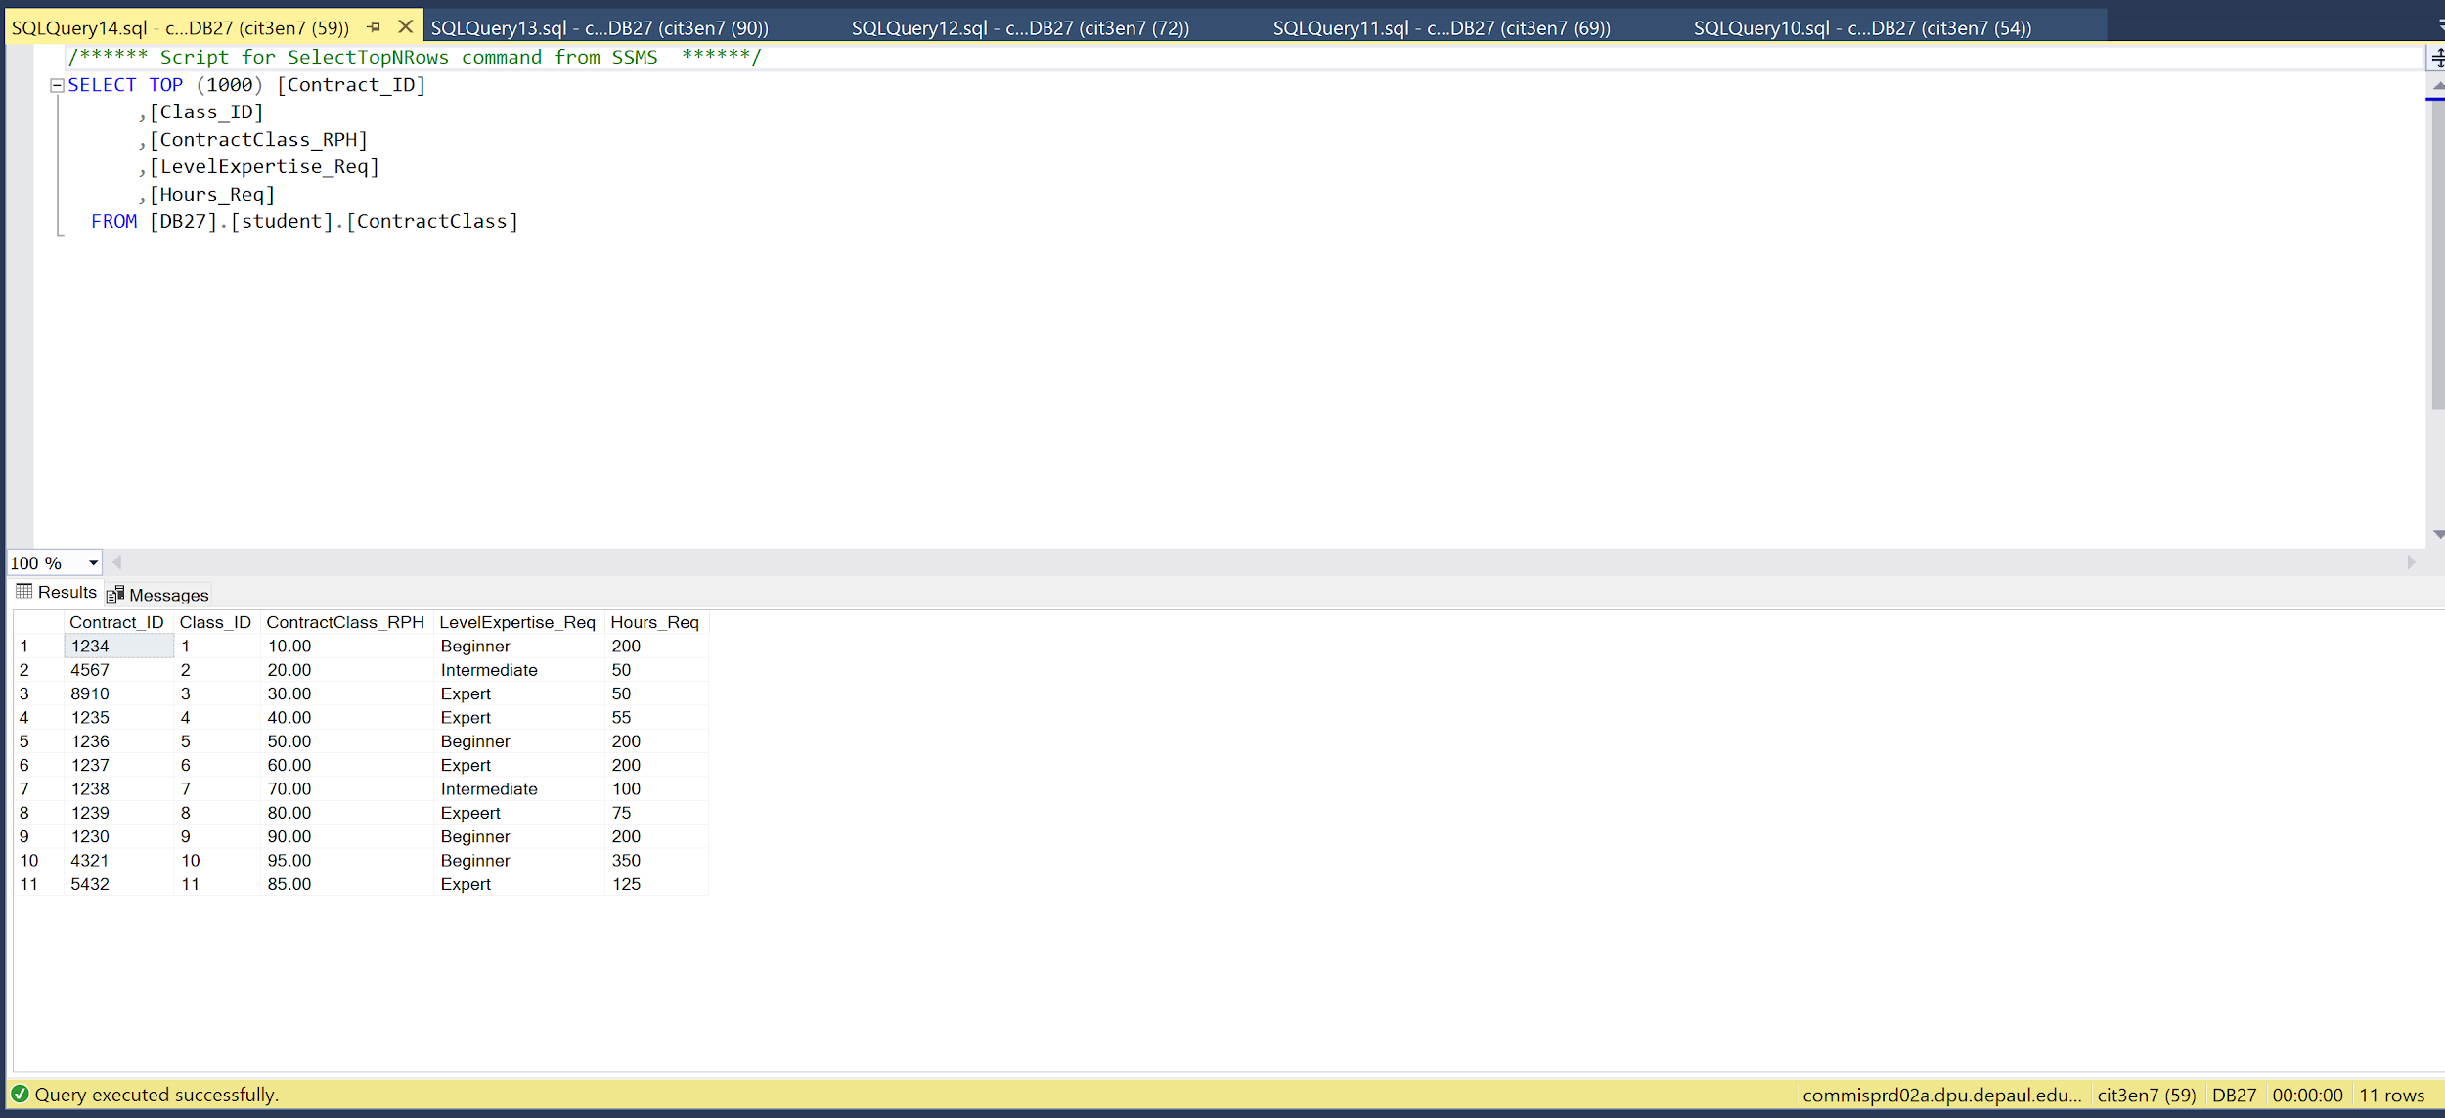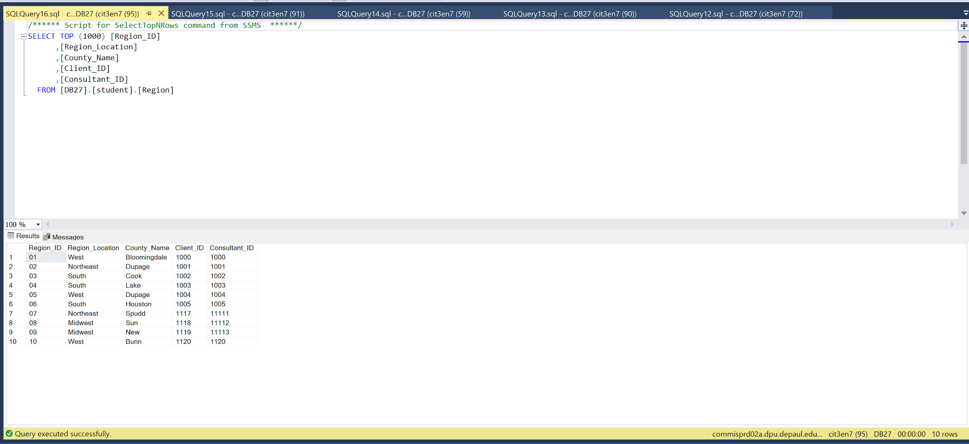

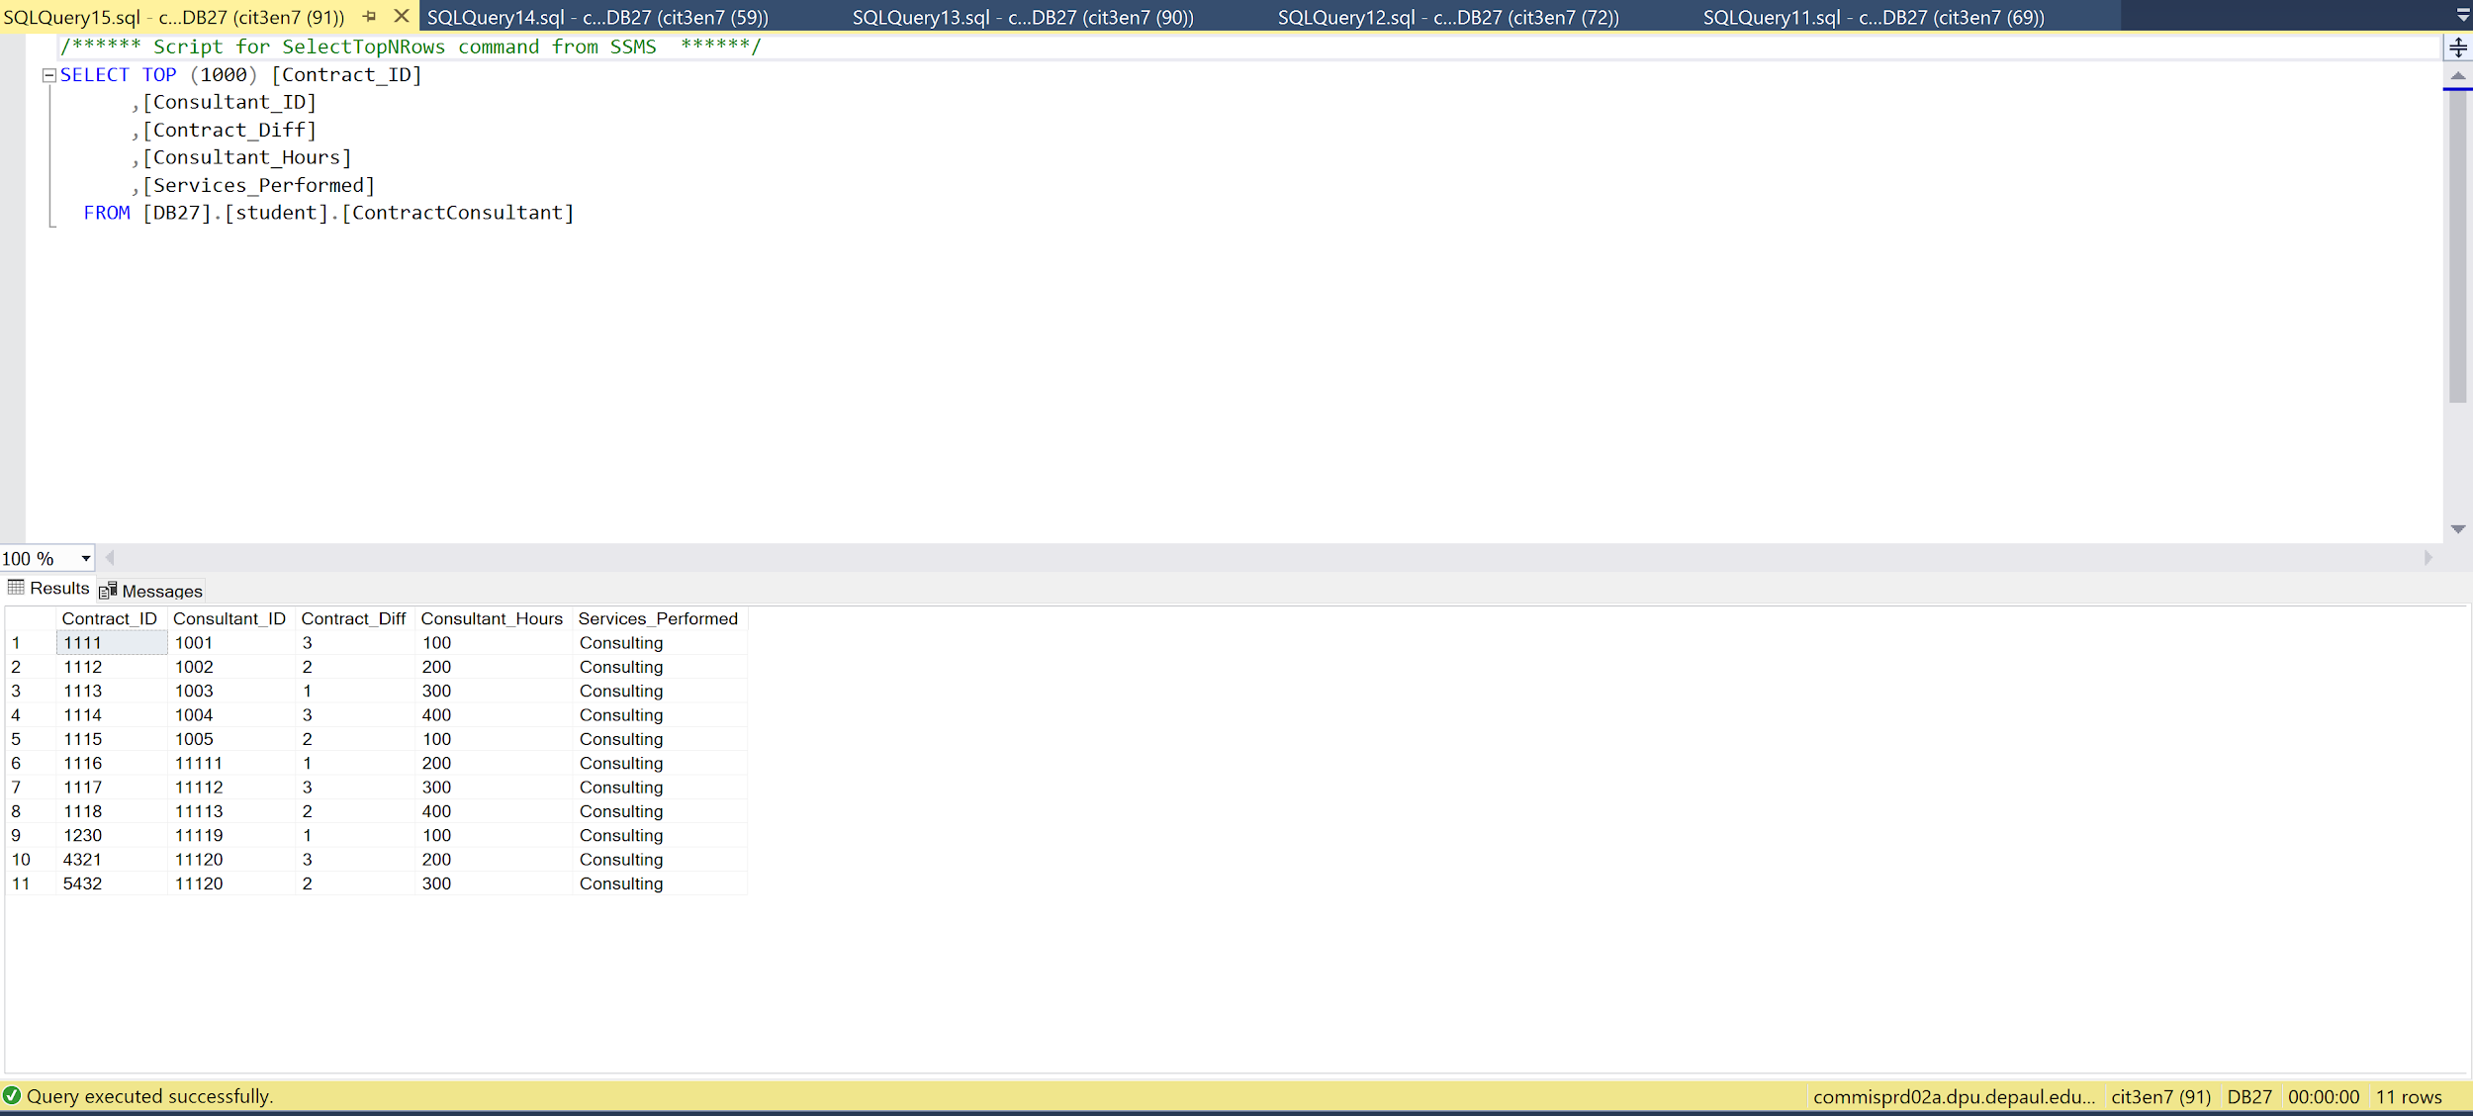

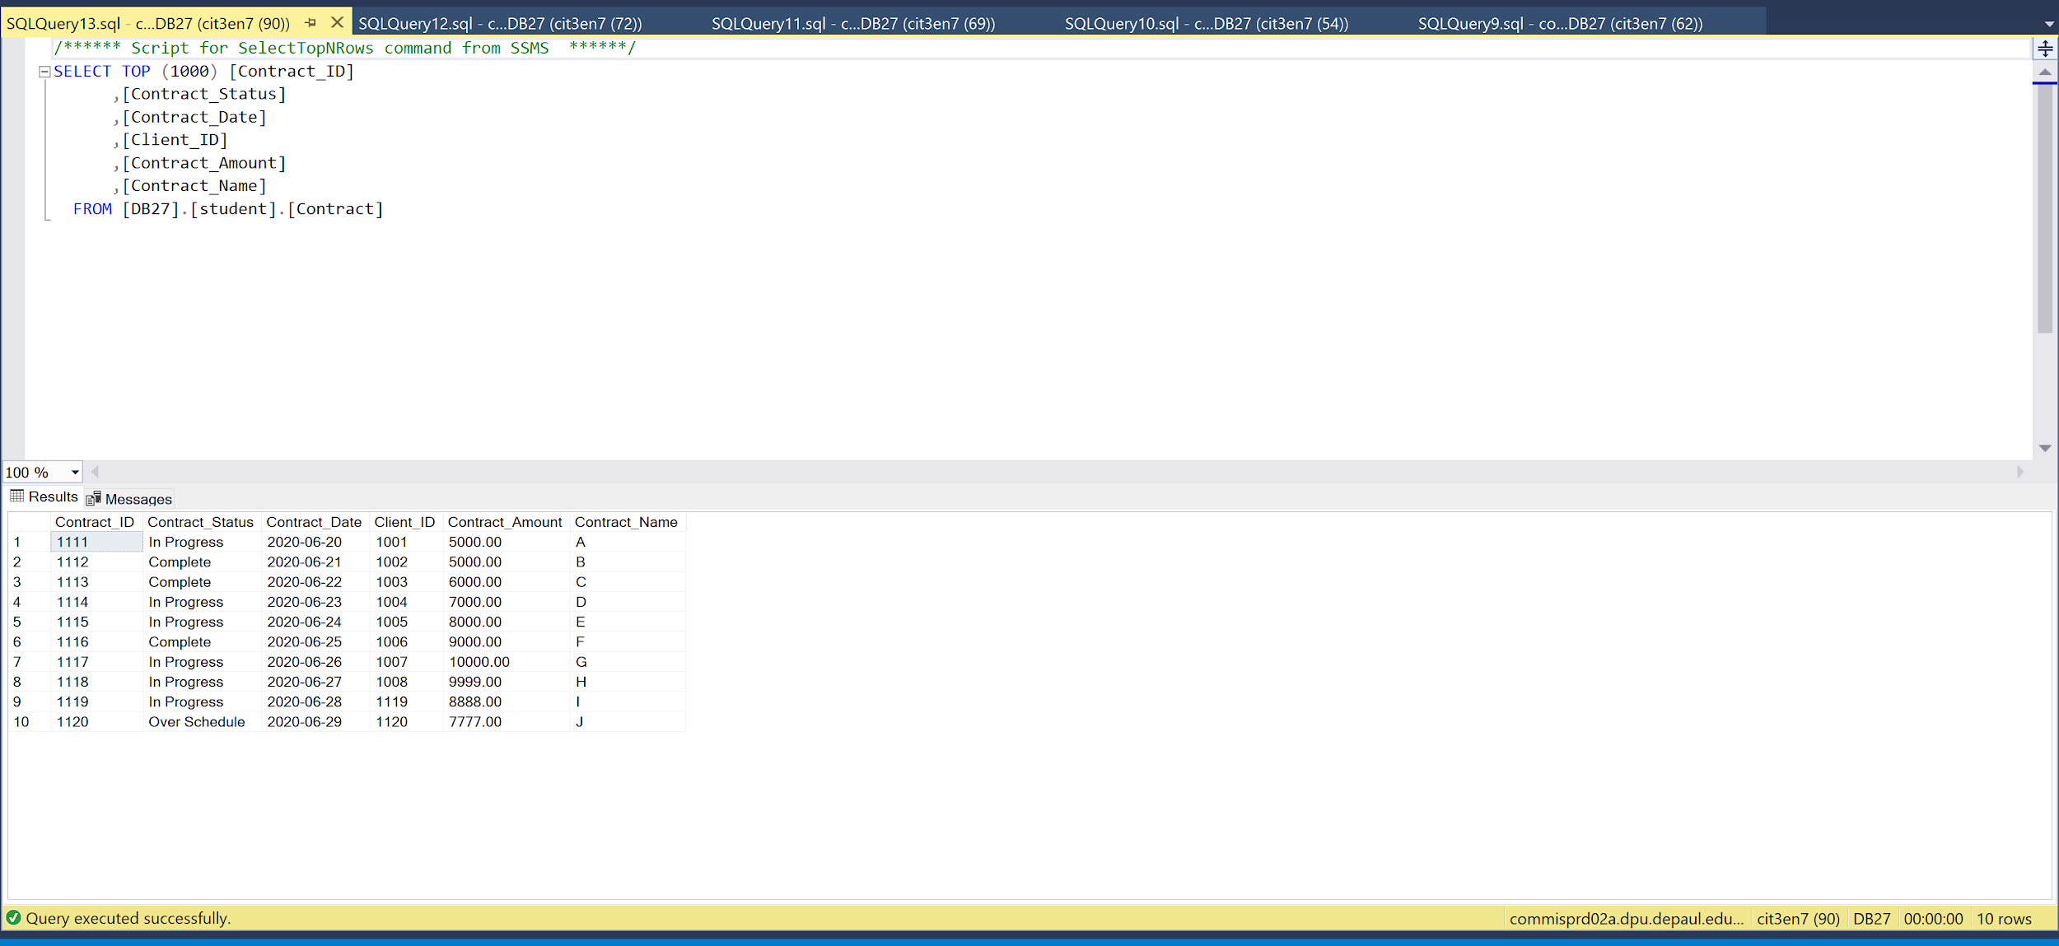

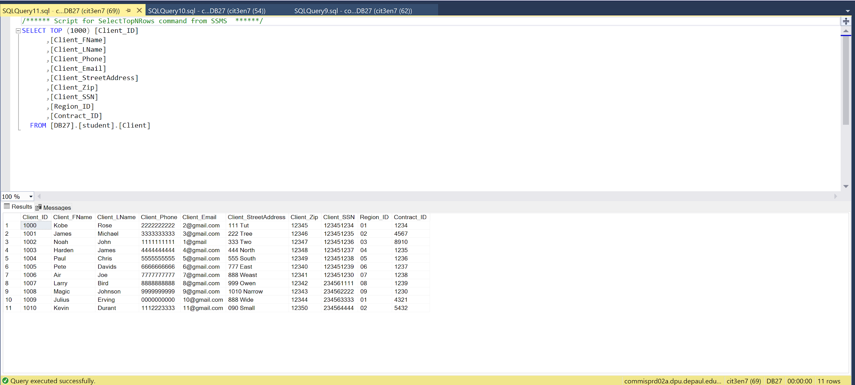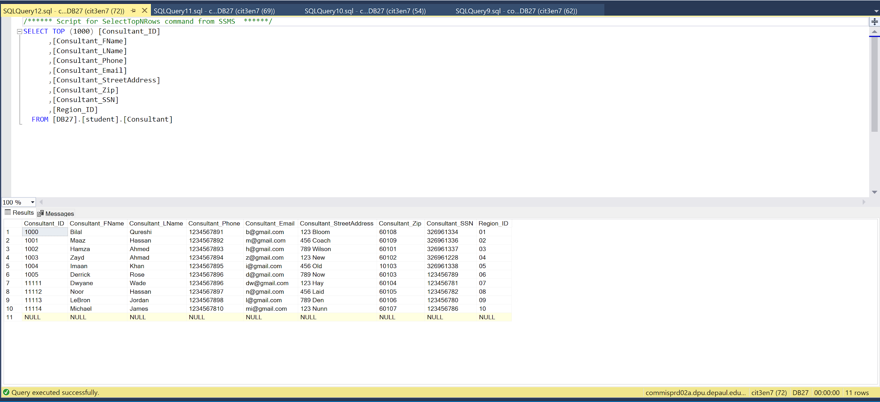

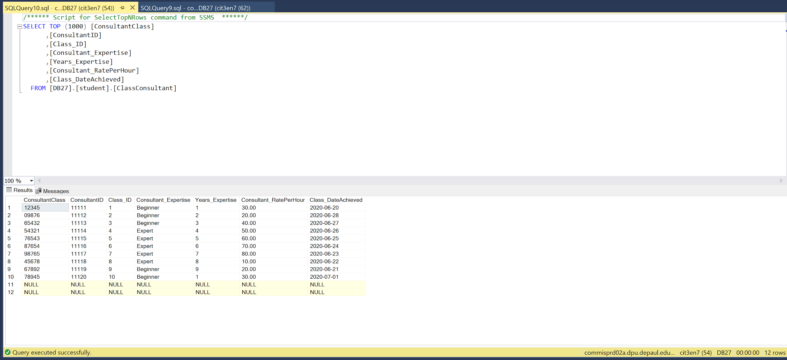

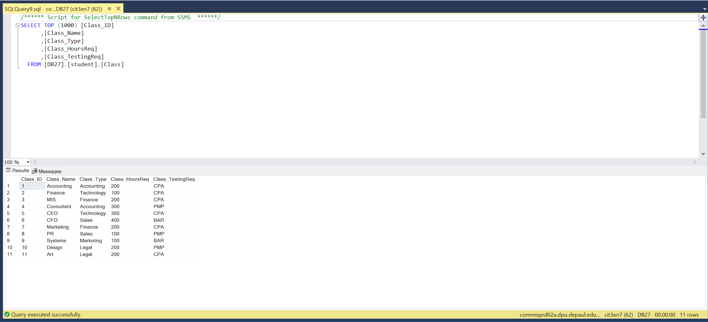

**Table Designs**

**Region Table:**

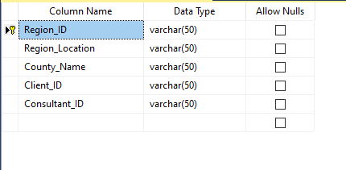

**Contract Table:**

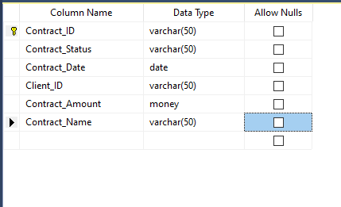

**Consultant Table:**

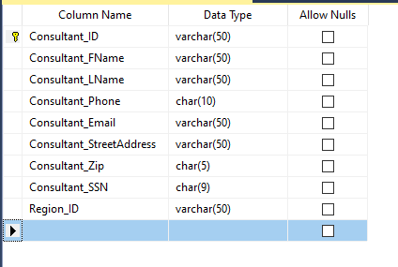

**Client Table:**

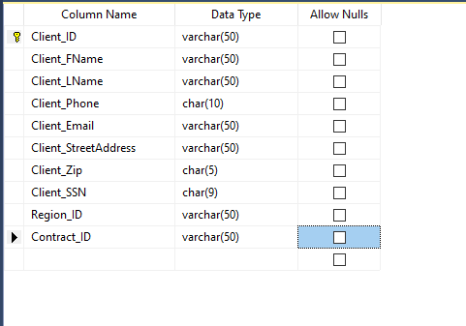

**ClassTable:**

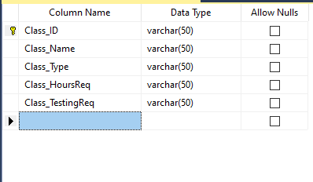

**ClassConsultant Table:**

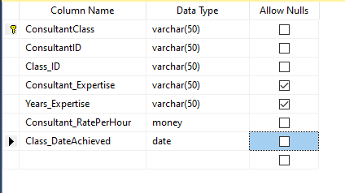

**ContractConsultant:**

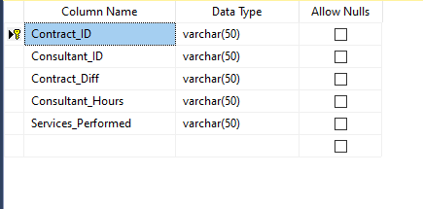

**ContractClass:**

